**Exercise 7: Financial Forecasting**

**Scenario:**

You are developing a financial forecasting tool that predicts future values based on past data.

**Steps:**

1. **Understand Recursive Algorithms:**
   * Explain the concept of recursion and how it can simplify certain problems.
2. **Setup:**
   * Create a method to calculate the future value using a recursive approach.
3. **Implementation:**
   * Implement a recursive algorithm to predict future values based on past growth rates.
4. **Analysis:**
   * Discuss the time complexity of your recursive algorithm.
   * Explain how to optimize the recursive solution to avoid excessive computation.

**SOLUTION:**

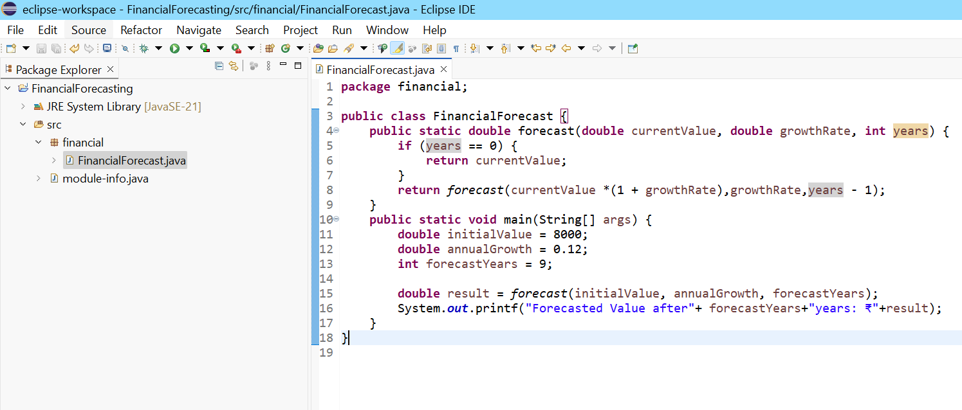

**OUTPUT:**

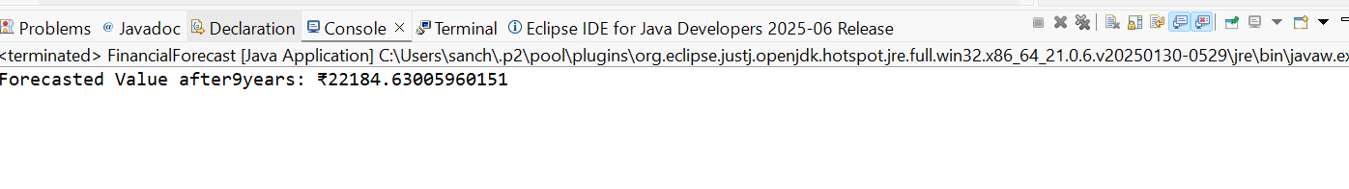

**Explain the concept of recursion and how it can simplify certain problems.**

Recursion is a programming concept where a function calls itself to solve smaller instances of the same problem.

How Recursion Simplifies Problems

* Breaks complex problems into simpler sub-problems
* Naturally fits problems with repetitive patterns or tree-like structures
* Leads to cleaner and shorter code (sometimes easier to read)

**TIME COMPLEXITY:**

O(n),as each recursive call reduces years by 1.

**How to optimize the recursive solution to avoid excessive computation?**

Use Iteration Instead.